Nepal College of Information Technology
Balkumari Lalitpur
Unit Test Spring Semester 2008

Year: 2008 FM: 70
Sem: II PM: 35
Program IT Time: 2hrs

Network Theory
Attempt All questions.

1. a) In the given circuit, switch K is moved from position 2 to position 1 at time t=0, steady state condition having established prior to switching. Find the expression for the particular solution for the current in the circuit. [8]
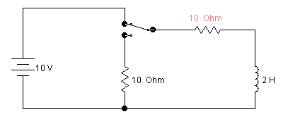
1
2
K
b) In the given circuit, switch K is closed at time t=0. Find the values of i, di/dt and d²i/dt² at t=0. [6]
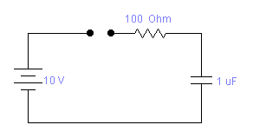
100 Ω
1 μF
10 V
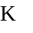

2. a) In the series RLC network, R=4Ω, L=1H and C= 0.2 F. The network is supplied by step voltage of 5 volts at time t=0. It is required to obtain the particular solution for i(t).Use classical approach. [7]
b) Solve the following non-homogeneous linear differential equation for t≥0. [8]
d²i/ dt² + 4di/dt + 3i = e^{-3t}

3) a) An exponential current 2e^{-3t} is applied at time t=0 to a parallel R-C circuit comprising resistor R=1/2 Ω and Capacitor C=1F. Using Laplace transformation, obtain complete particular solution for v(t) across the network. Assume zero initial charge across the capacitor before application of current. [7]
b) A step d.c. voltage of 4 volts is applied to a series R-L-C circuit consisting of resistor R= 4Ω, inductor L=4H and capacitor C= 1F. Obtain the particular solution for the current i(t) through the circuit. Use the Laplace transformation method. [8]
4) a) For the given network, find the transfer functions G₂₁(s), Z₂₁(s) and driving point impedance Z₁₁(s). [7]
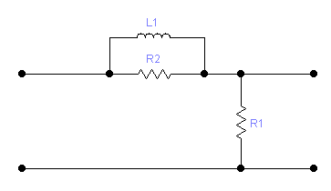
I₁(s)
V₁(s)
V₂(s)
Ls
R₁
R₂

b) Apply Routh criterion to the following equation and determine the number of roots with (i) positive real parts (ii) negative real parts and (iii) zero real parts. [7]
s³ + 2s² + 5s + 2 = 0
5) Write short notes on the following [4*3=12]
a) Initial and Final Value theorems.
b) Poles and Zeroes of a network function.
c) damping coefficient of second order system.

